

**Optimization Project report**

**CS03**

**Group 7**

|  |  |
| --- | --- |
| Student ID | Name |
| 1004900 | Neo Yew Young |
| 1007908 | Shi Jiaxin |
| 1007895 | Harini Narayanan |
| 1007840 | Min Jiarui |

**Model 1 (Work Shift Scheduling):**

**Problem:**

The scenario of our project involves starting a small food delivery business within SUTD, operated by the four of us as delivery riders. As this is a collaborative effort to hustle through university together, we aim to evaluate an optimal solution that ensures a fair and realistic workload for each member. The objective of the project is to minimize the number of riders scheduled for each one-hour shift while fully meeting the hourly demand.

**Model:**

Assume that our work schedule is divided into hourly segments within each day. We can approach the problem by considering the food delivery demand at each hour and deciding which of us should be on shift during that time. The decision of how many and which members to schedule per hour can be modelled as an ILP: Let each driver be indexed by $i∈\left\{1,2,3,4\right\}$, where each $i$-th driver has a different fixed productivity level. Let each hourly time interval within a day be indexed by $j∈\left\{1,2,...,24\right\}$ where the demand in each $j$-th hour varies based on survey data collected from the SUTD community.

**Decision variables:**

For each driver, $i$ we assign a binary variable $x_{i}∈\left\{0,1\right\}$ that indicates whether driver $i$-th is employed.



**Constraints:**

The only constraint here is that the sum of orders completed by all drivers within each hour is more than or equal to the demand for that hour, i.e.

$$\sum_{i=1}^{4}{}p_{i}*x_{ij}≥d_{j} , ∀ j = 1, ... 24$$

**Objective function:**

We want to minimize the number of riders scheduled for each one-hour shift. Where,

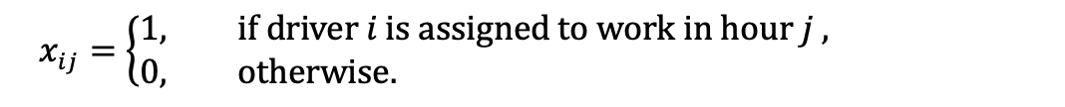

Then our ILP is

$$min\sum_{i=1}^{4}{}\sum_{j=1}^{24}{}x_{ij}$$

*s.t $\sum_{i=1}^{4}{}p_{i}*x_{ij}≥d_{j} , ∀j=1,...,24$*

$$x_{ij}∈\left\{0,1\right\}, ∀i=1,...,4 ; j=1,...,24$$

$d_{j}≥0$*, $∀j$ =1...,24*

**Correctness of model**:

1. **Variables:**

* $p_{i}*x_{ij}$ shows the number of orders fulfilled by the i-th driver in the j-th hour, multiplied by whether or not he is employed at that hour.

**E.g.:** driver 1 with $p_{1}=3$ employed in the 2nd hour.

${ x}_{12}= 1, p_{1}*x_{12}=3*1=3$ Orders fulfilled.

driver 2 with $p_{2}=4$ not employed in the 2nd hour.

${ x}_{22}= 0, p_{2}*x_{22}=4*0=0$ orders fulfilled.

* $\sum_{i=1}^{4}{}p_{i}*x_{ij}$ for j= {1...24}. $p_{i}$ represents the sum of orders fulfilled by **all 4** drivers in the j-th hour.

1. **Constraints:**

* For the constraint $\sum_{i=1}^{4}{}p_{i}*x_{ij}≥d_{j} , ∀ j = 1, ... 24$. ,
  + E.g.: Consider $d_{5}= 20$ and $x_{15}=3$, $x_{25}=2$, $x_{35}=3$, $x_{45}=4$ and all drivers are employed

$\sum_{i=1}^{4}{}p_{i}*x_{i5}= ($ 3*1) +(2*1) +(3*1) +(4*1)

= max 12 orders fulfilled <20 (infeasible)

Therefore, it is not feasible for **all** cases and needs to be addressed.

**Feasibility in Real-Life Context:**

1. **Productivity Constraints and Infeasibility in High-Demand Hours**

We arbitrarily set the productivity vector as $p=\left[3, 4, 2, 1\right]$, where each entry represents the fixed number of orders a driver can fulfill per hour. Because of this, the model may become infeasible for certain high-demand hours where the total number of orders placed in that hour is higher than the sum of all drivers’ productivity. i.e. $\sum_{i=1}^{4}{}p_{i}=10 .$

Therefore, if the demand $d_{j}$ in any hour $j$ exceeds 10, it is impossible to satisfy the constraint $\sum_{i=1}^{4}{}p_{i}x_{ij}≥d_{j}$, regardless of how many drivers are scheduled. In such cases, the ILP has no feasible solution under the current productivity assumptions.

To resolve infeasibility, we can increase productivity values, but this is unrealistic in our context. As outlined in the problem statement, we are full-time students managing this delivery business alongside our academic responsibilities. Therefore, arbitrarily increasing productivity levels would fail to reflect the practical constraints associated with balancing work and study commitments.

1. **Having a high productivity (p vector) to overcome high demands during peak hours**

If we set the productivity vector p to high values (e.g., p = [30, 40, 20, 10], assuming each of us is highly productive and can deliver a large number of orders per hour), the problem’s optimal solution will always choose the highest productivity driver first. Hence, this problem is inherently trivial and is easily solved using a greedy approach.

1. **Introduce an indicator variable to model a fifth driver (x₅) who only works when demand in any hour (Di) exceeds the maximum productivity of the 4 riders in 1 hour.**

Assuming the maximum productivity of all drivers is 10, we have the following implication: $D_{i}>10 =>δ=1=>x_{5j}=1$

We can split this into 2 logical implications:

$δ=0:D_{i}≤10+M_{1}(δ)$ [However, this logical implication is not required because Di is gotten from the data]

$$δ=1: X_{5j}≤1+M_{2}(1-δ)$$

We want $δ=0$ to model the condition of driver 5 (X5j) not being able to be activated for any hour and $δ=1$ to model the condition of driver 5 (X5j) being an available option.

Solve for M2:

When

When $δ=0, X_{5j}≤1+M_{2}(1-0)=X_{5j}≤1+M_{2}(1-0)$. Hence $M_{2}$ should be -1 to force X5j to be 0 when $δ=0$.

**Model 2 (Capacitated Facility Location):**

**Problem:**

Our new scenario involves starting a small business within SUTD, operated by the four of us as delivery riders. In this problem, each of us begins at different locations across campus, and we are tasked with fulfilling delivery demand at five distinct food pickup locations. The objective of the project is to ensure that the demand at each customer location is fully met.

**General Model (for $j=\left\{1,...,24\right\}$):**

We approached the problem by considering the order demand at each hour (based on the data), distributed across the five delivery hotspots. Each hour will have a random distribution of demand among the hotspots, resulting in a distinct optimal solution for each time interval. The driver compensation model includes a fixed salary for each hour a driver is activated and a variable cost component that depends on the distance travelled per order. The decision of how to minimize the total operational cost of delivering food to each delivery hotspot within an hour can be modelled as a MILP: Let each driver be indexed by $i∈\left\{1,2,3,4\right\}$, $j∈\left\{1,2,...,24\right\}$ represent the hourly time intervals within a day, and $k∈\left\{1,2,3,4,5\right\}$ denote the delivery hotspots.

**Decision variables:**

For each driver $i$, we assign a binary variable $y_{ijk}∈\left\{0,1\right\}$ that indicates whether driver $i$ is assigned at hour $j$ at hotspot $k$.

Each driver gets a fixed base pay at hour j.

$c_{f}: fixed cost to activate driver i at hour j$ 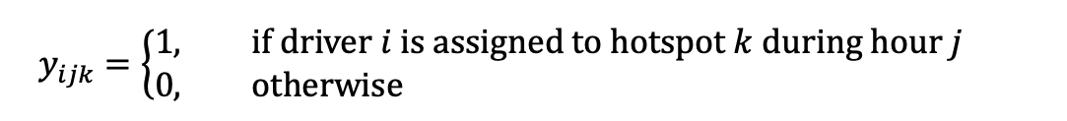

For each driver, there is a variable distance depending on how far the distance of the hotspot is from the driver’s starting location.

$$x_{ijk}: Distance that driver i at hour j has to travel for delivery hotspot k$$

$$C_{ijk}: Cost per distance that is paid to driver i at hour j to fulfill order i at hotspot k$$

$$d_{jk}: Demand at hour j at hotspot k$$

$$d_{jk}, x_{ijk}, C_{ijk} ≥0$$

**Constraint:**

The sum of all drivers assigned to delivery hotspot k in an hour must be more than or equal to the demand for that hour at hotspot k.

$\sum_{i=1}^{4}{}y_{ik}^{}p_{i}≥d_{ik}, ∀j$ =1...,24**, $∀k$** =1...,5

**Objective function:**

We want to minimize the total operational cost in a day. This is given by the sum of fixed hourly activation fees for drivers and the variable transportation expenses incurred based on the distance each driver travels to meet the demand at each hotspot at each hour.

$$minimise \sum_{i=1}^{n}{}c_{i}y_{i}+ \sum_{i=1}^{n}{}\sum_{j=1}^{24}{}\sum_{k=1}^{5}{}c_{ijk}{x }_{ijk}$$

In our model, we will only be focusing on the peak demand hour and solving per hour to prevent an aggregated solution that is hard to interpret. Thus, the objective function that we are solving is:

$$minimise \sum_{i=1}^{n}{}c_{i}y_{i}+ \sum_{i=1}^{n}{}\sum_{k=1}^{5}{}c_{ik}{x }_{ik}$$

Then, our MILP is:

$$min \sum_{f}{}c_{f}y_{f}+ \sum_{i}{}\sum_{f}{}c_{if}x_{if}$$

$$s.t. y_{f}∈\{0,1\}$$

**Correctness of model:**

* For the constraint $\sum_{i=1}^{4}{}y_{ijk}^{} p_{i}≥d_{ik}$**,** when $y_{ijk}$ =0 (that is the driver is not hired) then the constraint becomes $\sum_{i=1}^{4}{}y_{ijk}^{} p_{i}$ = 0 (which satisfies the constraint of $d_{jk}$ > 0).
* When $y_{ijk}$ =1, $\sum_{i=1}^{4}{}y_{ijk}^{} p_{i}$ = $\sum_{i=1}^{4}{}p_{i}$ $≥d_{ik}$**,** this means that the total productivity of the 4 drivers must be greater than or equal to the total demand for food delivery during that hour. If the productivity is less than the demand for a particular hour, the solution becomes infeasible. We have discussed further in the discussion section below.

**Discussion Section:**

* **Infeasibility**

$\sum_{i=1}^{4}{}y_{ijk}^{} p_{i}$ = $\sum_{i=1}^{4}{}p_{i}$ $≥d_{ik}$ does not hold feasibility in all cases. For example, if the demand $d_{ik}$ exceeds the maximum number of orders when all drivers are employed, it is impossible to meet all of the demand. Hence, there needs to be an additional constraint, preferably by having a set of substitute drivers (e.g. 3 substitute drivers) who are activated by an indicator variable $δ_{} = [δ_{1},δ_{2},δ_{3}]$ for $l$ =1,2,3 . Each substitute driver $l$ will have their own set of productivity. For example, $p_{s}=[5,6,7]$. So, if substitute drivers 1 and 3 are employed, $δ_{s}$ = [1,0,1]. Total orders fulfilled by the substitute drivers is given by $\sum_{l=1}^{3}{}δ_{l}p_{l}$, which will be added on to the maximum total orders fulfilled by the original 4 drivers.

* **TSP formulation:**

From our research & experience, a delivery driver will go from restaurant to customer to restaurant before returning to their home, never going back and forth from a fixed location to the customer. This is one limitation of this model that could be addressed using the TSP formulation which models a single route starting and ending at the same point (Home). However, we decided to go with a facility assignment model because an increased number of hotspots and driver variables would be much slower to solve using a TSP formulation.

* **Preventing overreliance on most productive driver by adding variable cost**

In the current model, fixed driver productively value ($p=[6,8,4,2]$) impose upper bounds on how many orders each driver can fulfill. The only mechanism that prevents this lopsided assignment is the variable cost component, which increases with distance traveled. This encourages shorter trips and a more even distribution of work. Some examples of variable cost components that discourage assigning all orders to the most productive driver:

1. **Enforce rest time to prevent continuous assignments.**

Adding a constraint that if a driver is active in hour $j$, they cannot work in $j$ +1.

i.e. ${\sum_{k=1}^{5}{}y_{ijk}}_{}+\sum_{k=1}^{5}{}y_{i,j+1,k'}≤1 ∀i,j∈\left\{1,...,23\right\}$

1. **Fatigue-based productivity Decay**

We can reduce driver’s effectiveness the more they work. By introducing a binary variable $z_{i}$ to reduce driver productivity after a certain number of active hours.

i.e. $x_{ijk}≤p_{i} (1-z_{i})+r_{i}⋅z_{i}$

If $z_{i}=0, then x_{ijk}≤p_{i}$

If $z_{i}=1, then x_{ijk}≤ r_{i}=0.5 p_{i}$

**Appendix**

**Solving an instance using JuMP (Model 1):**

First solve (using p row vector [30 40 20 10]):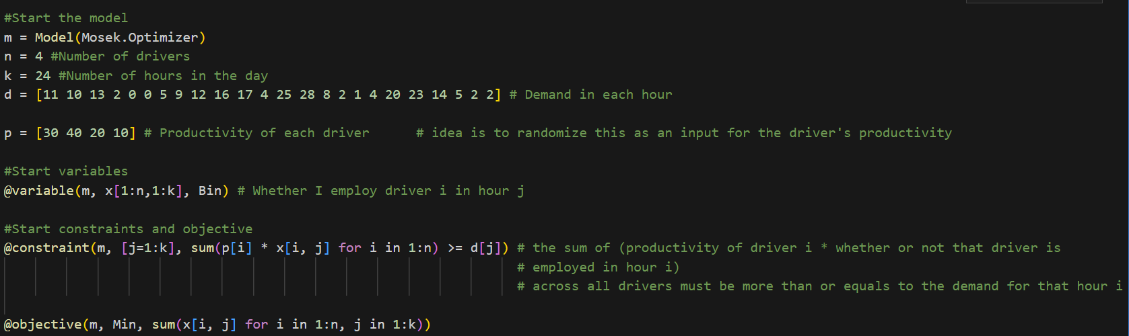

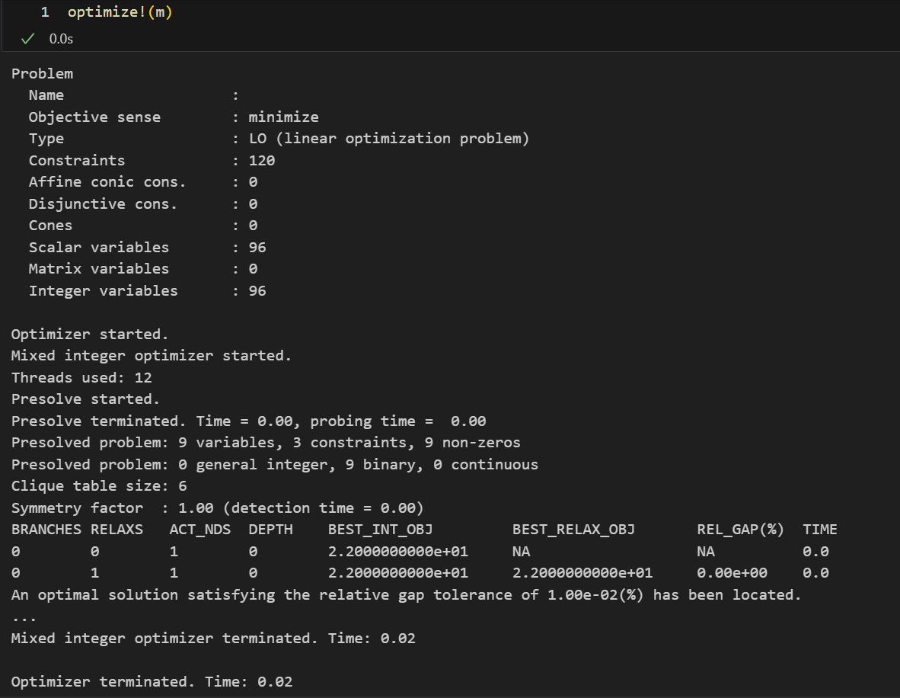

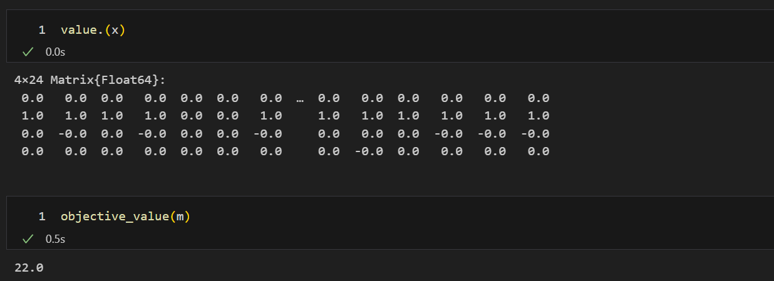

Second solve (using p row vector [3 4 2 1]):

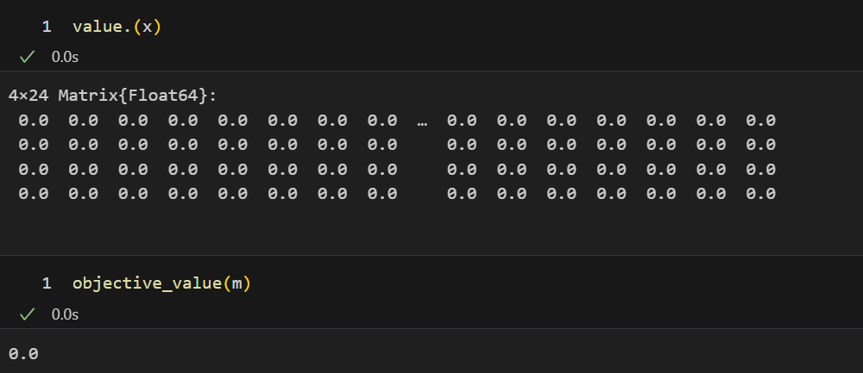

**Solving an instance using JuMP (Model 2):**

First formulation of the model solving for hour 1:

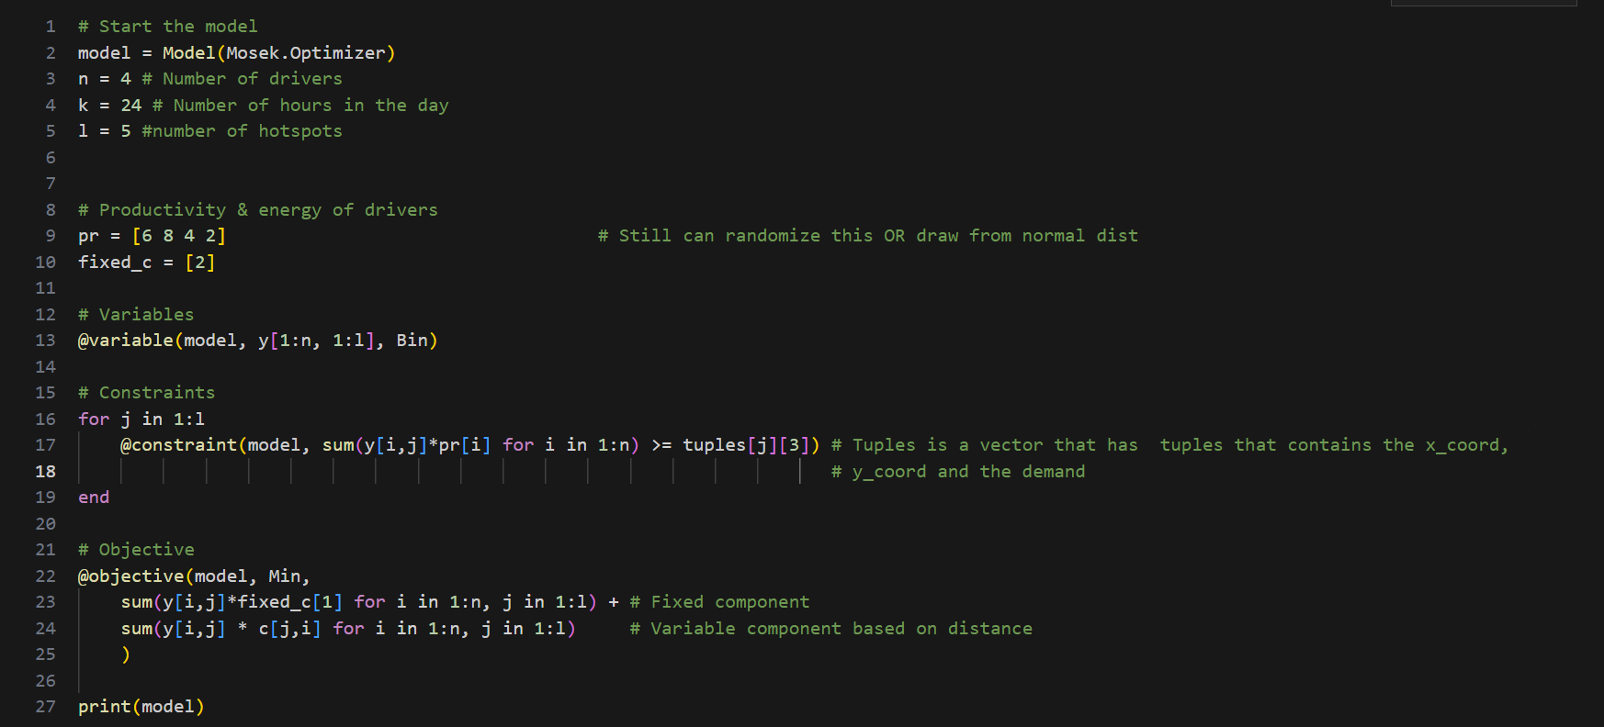

First solve using a p vector of [6 8 4 2]:

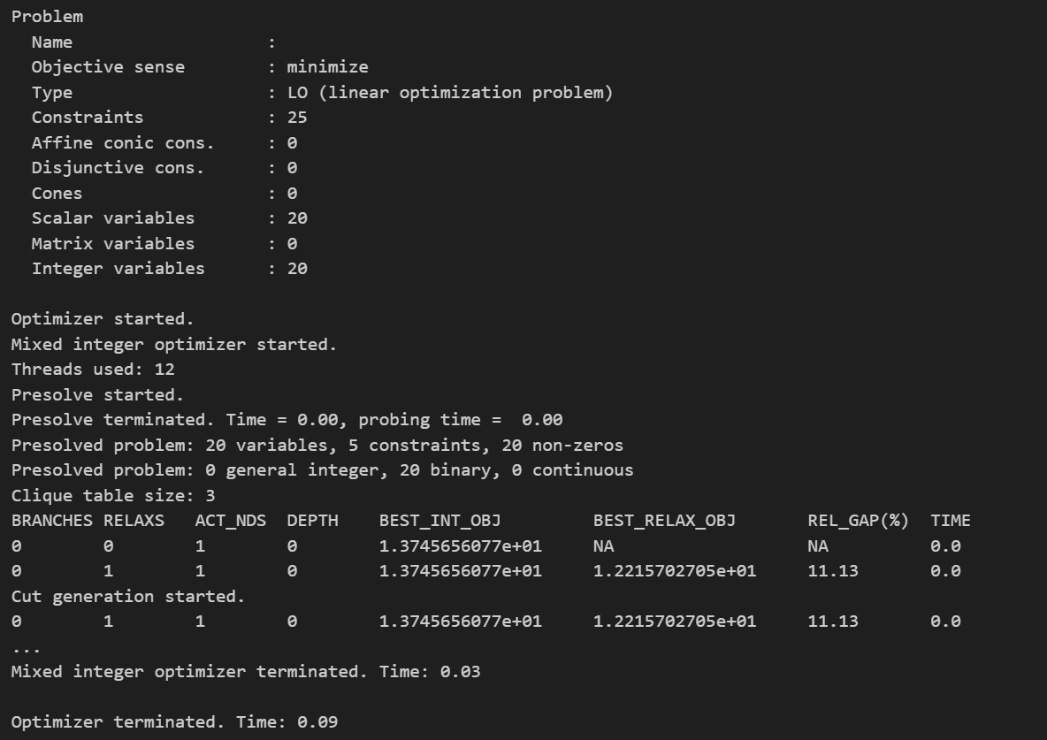

Solution and objective function value of 13.71 units of cost:

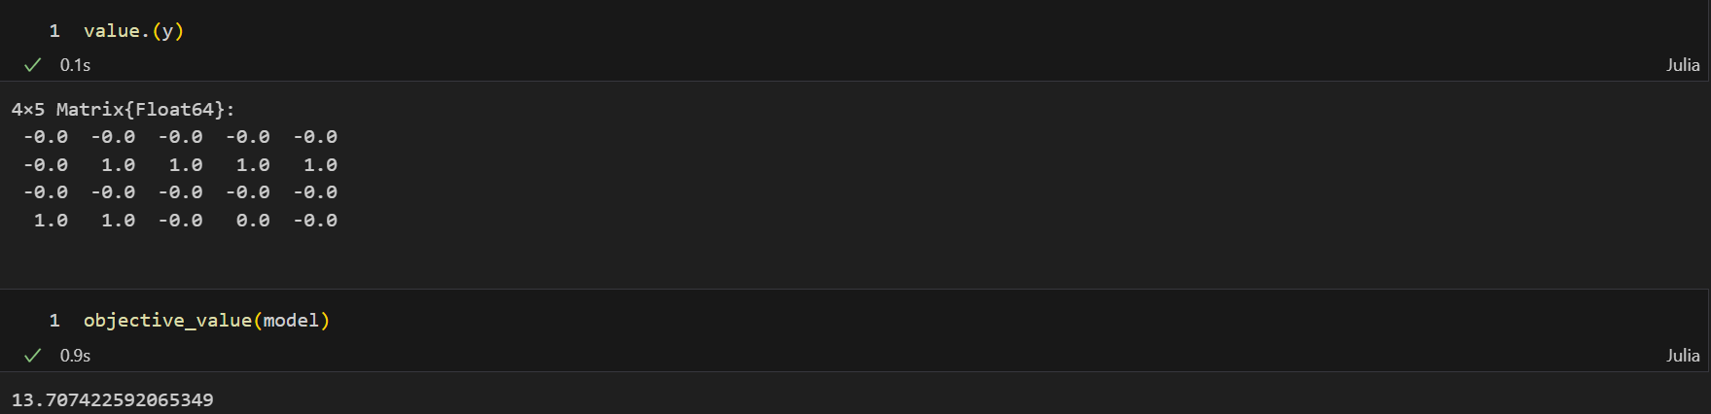

**Facility graph visualization:**

